MatchRef

User Guide 2022

Once your details have been loaded into MatchRef you will receive a Welcome Email with instructions on how to log in. Once you are logged in please read the Getting Started Guide from the left hand side menu. Below is further instructions on some of the menu items.

Part 1 – My Details

- Please ensure all your personal details are correct.
- Enter your Home Zone – see My Zones for an explanation
- Show Mobile – this allows referees who are appointed together to contact one another if they are running late, to organise transport or to confirm they will be at the game
- Email recipients – if you want all emails to go to a second email address as well as yours please change to Also Send to Secondary and ensure you have entered the secondary email address

Part 2 – My Zones
The MWFRA has divided the Manly Warringah Area into 5 zones
- Northern Zone – from Narrabeen to Avalon
- Central Zone – Collaroy to Dee Why at to Allambie Oval
- Eastern Zone – from Brookvale to Seaforth
- Western Zone – from Seaforth to Killarney
- Southern Zone – From Balgowlah Heights to Mosman
The grounds that are included in each zone can be found on the MWFRA website - http://mwfra.org.au/appointments/ground-zones/

In this section you can indicate where you PREFER to referee. Click on the drop down arrow under Ground Zone, click on the Zone and click Create. The zone you have chosen will appear in the Declared Zone section. You can declare more than 1 zone. Zone Declarations are only your PREFERENCE. You may still be appointed outside your preferred zone but we do try to keep you as close to home as possible.

Part 3 – My Related Teams
This section allows you to enter any team you are related to so that you are not appointed when you are playing, or to a siblings or parents game

You cannot enter anything here until the draw has been released by the MWFA.

To enter the team you play for:
- Once the draw is published you should be able to see your team in the Team drop down box. Please note that each club can appear in a variety of ways (EG CCS, Cromer CS, Cromer Collaroy Strikers) so you may have to attempt a few different ways to find your team.
- Relationship – Player
- Unavailability – ensure this says UNAVAILABLE DURING MATCH
- Out of Zone – change to Ref out of Zone if team away. This allows you to be appointed to a match that is directly after yours if you are at an away game.
- Time between Matches – MatchRef unfortunately does not recognise that you are normally required to be at your field 30-40 mins before kick-off. It does take travelling time into account but not warm-up time. In the text box enter 30. This means it will exclude you from games 30 minutes before and after your own.
- Excluded until – enter the 31st December 2022.
- Click Create – and your team relationship will appear below in Existing Team Relationships.

Repeat this process for any family member teams changing the relationship to Related and AVAILABLE DURING MATCH. This will ensure that you are not appointed to a family members game but can still be appointed when they are playing.

Unfortunately MatchRef does not recognise A and B teams in the same division. If you are in a team such as this, please don’t enter your team relationship here as it will make you unavailable when both teams are playing. Please use the My Unavailability section to enter your unavailability when playing.

Part 4 – My Unavailability

Availability for the following week must be entered by MIDNIGHT each Sunday. It is recommended that you put an alarm on your phone that reminds you on Sunday night to ensure it is entered. At midnight on Sunday night the system is locked and you cannot change any entries for the following week. If you do need to make changes, please email the Appointments Officer – admin@mwfra.org.au – asap so it can be entered for you. Appointments are organised from Monday morning and if you make changes after this it can be very disruptive to the appointments process and delay the publication of appointments. Anyone who continually forgets to enter their availability will be excluded from the following week’s appointments.

Below are some examples of how to enter availability. The easiest method is to enter what days/times you are available for the next week on Sunday evening. Check with parents etc for other commitments before making yourself available. Once you make yourself available you are expected to honour that availability unless you fall ill or become injured.

How to Add when you are available.

EXAMPLE 1 – Available all-day Saturday 2nd April

- Date – Enter the Date you are available (in this case the 2nd April) using the drop down calendar
- Start Time – Enter the time from which you are available (if all day then leave as 6:00)
- End Time – Enter the time you are available till (if all day then leave as 23:00)

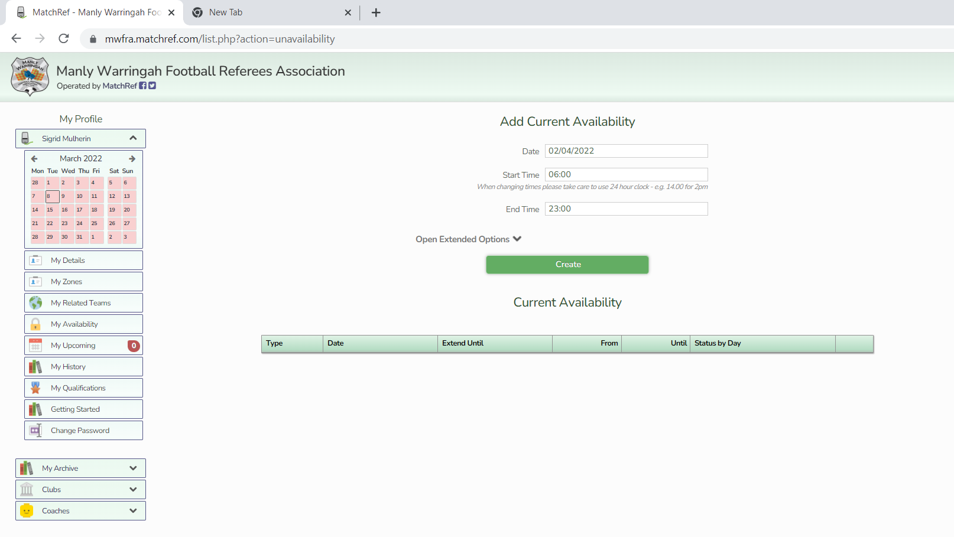

- Click Create – your screen will look like this if you have made yourself available on the 2nd April

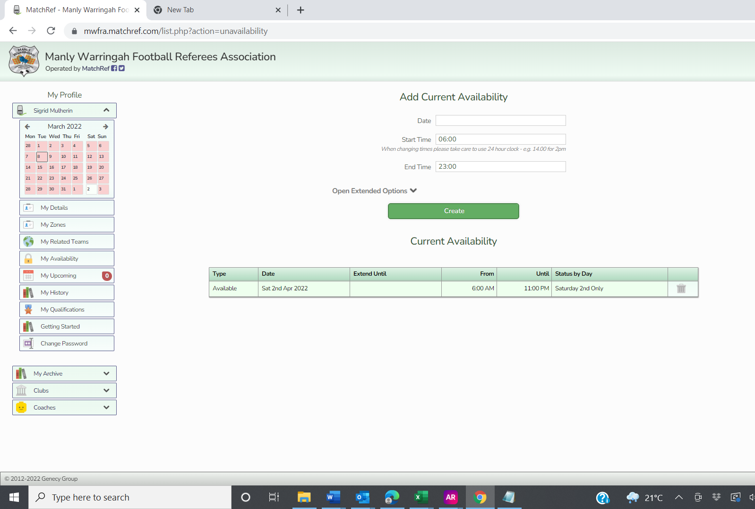

Please note the green square on the left hand side calender that indicates you are available.

EXAMPLE 2 – Available all-day Saturday 2nd April and Sunday 3rd April

- Date – Enter the first day of the week (in this case 28th March) using the drop down calendar
- Start Time – Enter the time from which you are available (if all day then leave as 6:00)
- End Time – Enter the time you are available till (if all day then leave as 23:00)
- Click on Open Extended Options
- Enter the last day of the week next to Extend Until
- Click in the box next to Monday – Friday so that ‘Included’ disappears
- Click Create

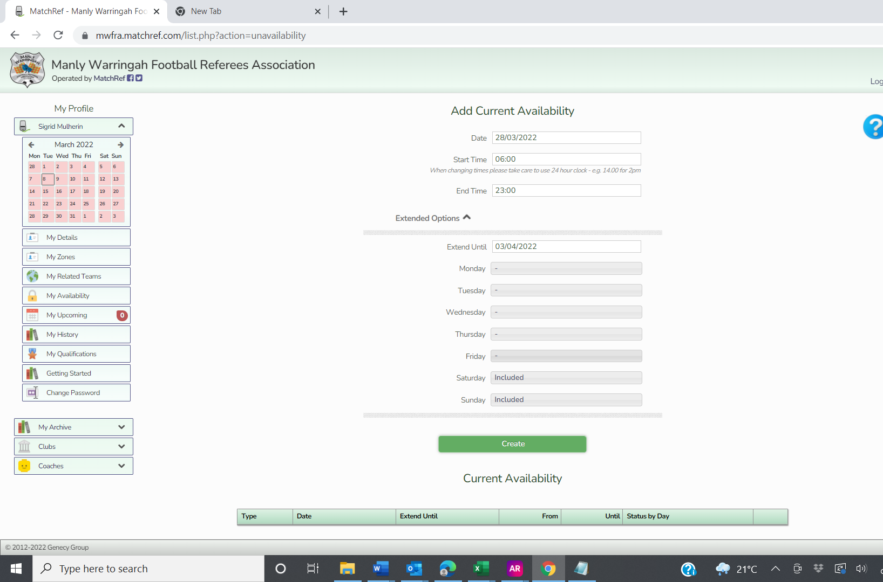

This is what it will look like after you have clicked create:

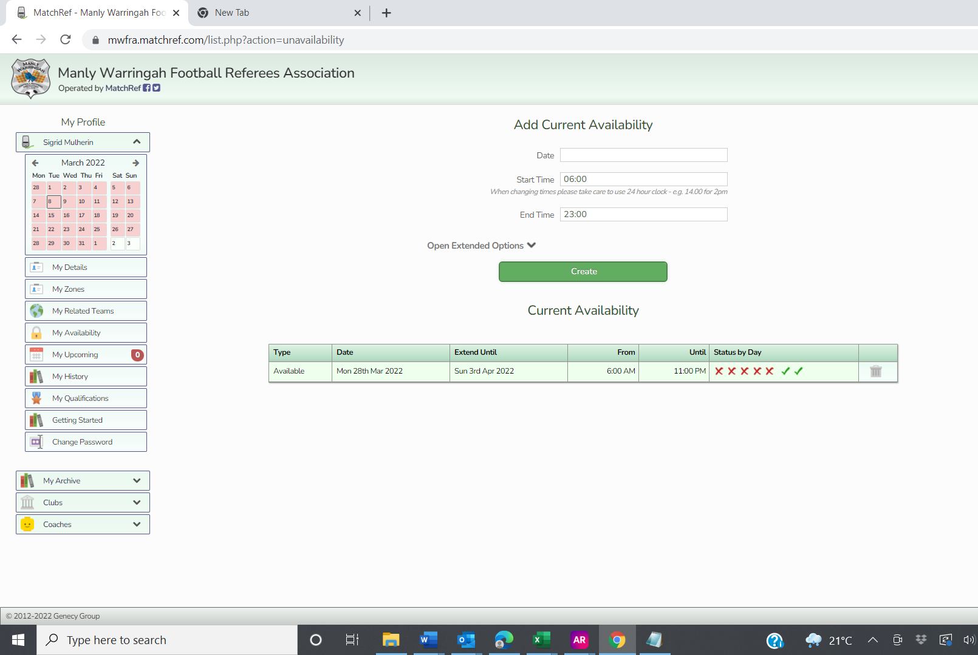

Notice the red crosses which correspond to Monday – Friday and the green ticks which correspond to Saturday and Sunday availability. And the two green boxes on the calendar.

EXAMPLE 3 – Available Saturday 2nd April from 1-3pm

NOTE; MATCHREF USES A 24 HOUR CLOCK TO AVOID CONFUSION

- Date – Enter the day you are available (in this example 2nd April) using the drop down calendar
- Start Time – Enter the time from which you are available (in this case 13:00)
- End Time – Enter the time you are available till (in this case 15:00)
- Click Create

Here is what it looks like after you have clicked Create. Note the yellow square on the 2nd April which indicates you are partially available for that day.

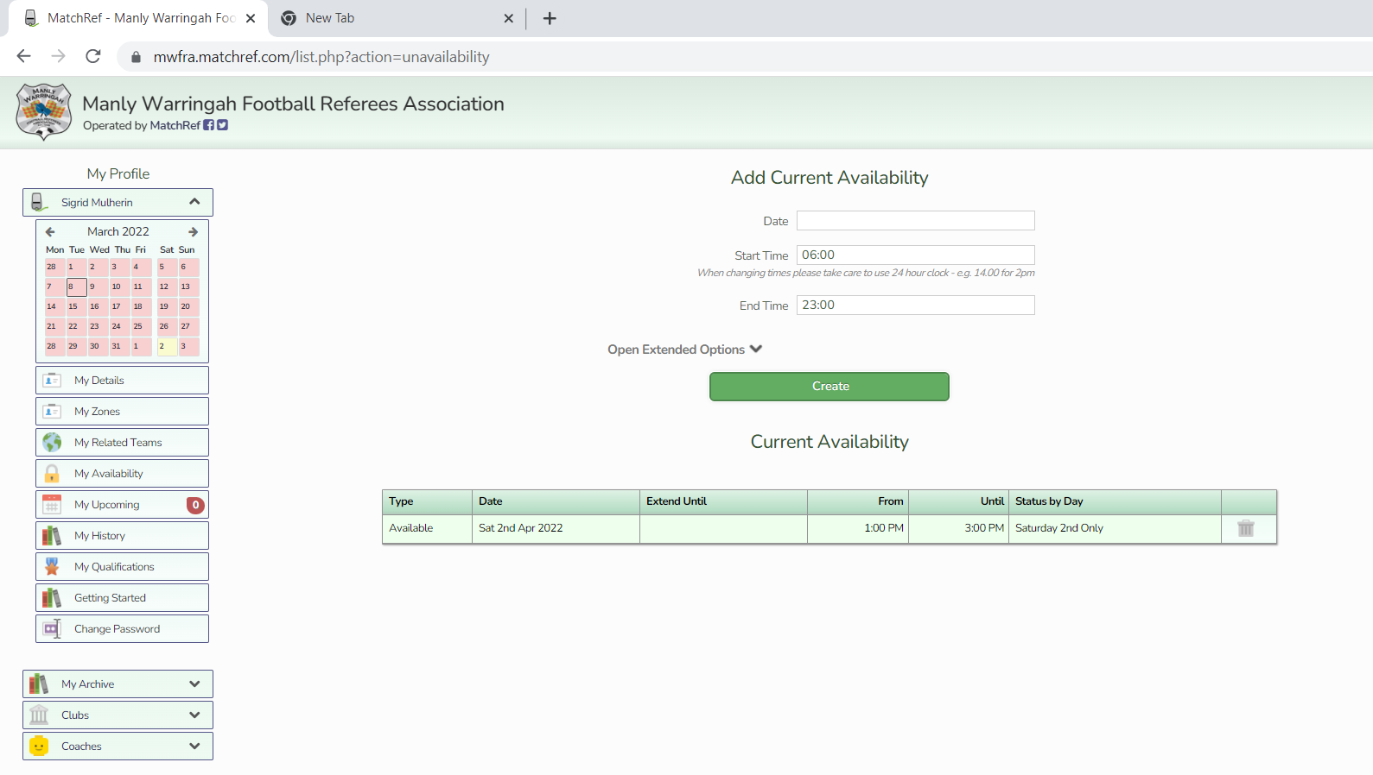

IMPORTANT

The calendar on the left hand side of the screen shows you what you have entered and when your games are. Please check this each week to ensure you have entered the dates and times correctly.

Red Square – unavailable
Green Square – available
Yellow Square – partially available
Small Triangle in corner – referee appointments on that day.

The garbage bins on the right hand side allows you to delete any entries you have made if you have made a mistake.

Part 5 – My Upcoming

This section will show you the details of the games you have been appointed to. The small number in the circle indicates how many games you are appointed to in the current week. Please check the details of the appointments carefully to ensure you know where and what time your game/s are.

Part 6 – My History

Once you start officiating at games this section will show you all the games you have refereed each season and how much you are paid for each game. Please check this periodically to ensure all games are shown.

Part 7 – My Qualifications

The MWFRA does not use this section

Part 8 – Getting Started

A brief overview on how to use MatchRef.

Part 9 – Change Password

You may use this if you want to change your password. If you forget your password there is a Forgotten Password button on the Log in Page of MatchRef

